Braille to Text/Voice Converter (BT/VC)
Bayan Halawani, Samer Isieed, Wisam Younes, Dr. Radwan Tahboub
College of IT and Computer Engineering, Palestine Polytechnic University, Hebron- Palestine
¹bayan.h2007@homail.com, ²si_1@live.com, ⁴eng.wisam-prates@hotmail.com, ³radwant@ppu.edu

ABSTRACT

Communication between people is a very important thing, sighted people use script provided by languages such as English or Arabic to write on papers. However, in case of people who are blind, they use a different type of script known as Braille to read and write.
The Braille to Text/Voice Converter (BT/VC) is a system that designed to help sighted people to be able to understand Braille script without any knowledge in Braille language.
INTRODUCTION

Braille is the system of reading and writing used by people who are blind where they feel raised dots on a Braille page with tips of their fingers.
The Braille script construct of cells, each cell contains 6 raised dots that arranged in three rows and two columns according to Figure 1, these six dots can be raised or flat according to the character, so these dots are used in combination to give 63(2⁶) different characters within a single cell._{[1]}
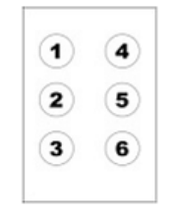

Figure 1: Braille Cell

A standard Braille page is 11 inches by 11.5 inches and typically has a maximum of 40 to 43 Braille cells per line and 25 lines, each cell has a specific dimensions between dots. The Braille language consists of three grades: 1, 2 and 3. In this paper we will focus on the grade 1 Braille paper in order to convert it to another language._{[2]}
In BT/VC, the Braille image is captured using modern mobile camera, then the Braille paper is stored as image in the storage device. After that, some image processing techniques applied on the image in order to make it ready for the next stage, which is applying BT/VC to the Braille image that’s convert each Braille cell individually to its equivalent binary code, and after we get a binary code. We send this binary code to a hash table in order get an ASCII code that represents a character.
BT/VC system offers many benefits to those who work with blind people, facilitating communication and reducing the gap between sight and blind people. For example: public organizations communicating with blind individuals, parents, and teachers. All people in workplaces where Braille is used can read Braille easily by using BT/VC system without have any knowledge in Braille.
Figure 2: image processing elements
LITERATURE REVIEW
Image processing is one of the computer science fields. Image processing operation goes into several steps; Figure 2 represents the image processing elements, including image acquisition, which is the first and the most important step in any pattern recognition system. The process of acquiring images digitally can be achieved by using a number of different equipments such as scanners or digital cameras or cell phones cameras_{[3]}. The next step is to apply some image processing algorithms including: converting the RGB to Gray scale image as shown in Figure 4 _{[4]}; then Separate the dots from the background using adaptive thresolding technique_{[5]} as shown in Figure 5, applying morphology techniques (erosion and dilation) that is used to enhance the dots and remove some noise as in Figure 6_{[3]}.
Figure 3: RGB image
Image preprocessing is an essential operation during this step, which eliminates some errors that may occur during acquisition; errors include noise, deformation, rotation, bad illumination or blurring.
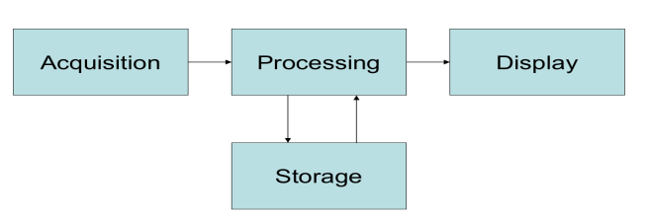
Image preprocessing can be used for image enhancement by reducing noise, sharpening images, or rotating a skewed page. Image processing element has to make some interaction with some storage device to give a new image and may display that image on an output device.

Figure 4: gray scale image
Figure 5: after adaptive thresholding

Figure 6: after morphology techniques applied

BT/VC ALGORITHM
The Braille image will be scanned using BT/VC algorithm that converts each cell individually.
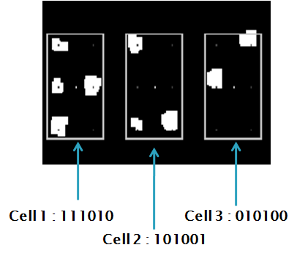
Figure 6, shows the operation of recognizing the cells and their dots and how to obtain a binary code from this Braille cells.
Figure 6: cell/dots recognition

CONCLUSION AND FUTURE WORK
According to the three Braille samples that have been tested in two situations using BT/VC algorithm, the ideal(artificial) image gives 99.6% correct results, and 0.4 incorrect results has been happened due to existing of some noise in the third sample. The ordinary captured sample gives 59.3% due to having a skewed angles and some noise that affects the results as shown in the following Table 1.
Table 1: Average reuslts for three samples
Sample  State | Ideal Image | Ordinary
Average(%) | 99.6 | 59.3

Future work will focus on multilingual scripts, improve the skewing images, improve BT/VC algorithm, and have more collaborative user interface.
ACKNOWLEDGMENTS
We would like to give a great thanks for the Deanship of Graduate Research and Dr.Sameer Khader in Palestine Polytechnic University for their financial support, which is represented in buying a Samsung Galaxy SIII that has been used in the implementation and testing of this project, in addition to covering a big part of cost for the courses that needed to build the application.
We would like to thank the manager of the Blind Association in Hebron Ms.Reem Tahboub, all teachers and students in the association for their cooperation.
REFERENCES
[1] Roy, Noëlle, Louis Braille 1809–1852, a French genius, Valentin Haüy Association website, retrieved 2011-02-05.
[2] http://www.brailler.com/braillehx.html &http://www.brailleworks.com/Resources/HistoryofBraille.aspx
[3] Gonzalez and R. Woods, Digital Image Processing, Addison-Wesley Publishing Company, 1992
[4] Susstrunk, Buckley and Swen. "Standard RGB Color Spaces”. 2005
[5]http://homepages.inf.ed.ac.uk/rbf/HIPR2/adpthrsh.htm

