Using Computer Vision for Plant Disease Detection
A case study for cucumber downy mildew disease
Nermeen Alam¹, Shahd Ewaw¹, Rami Arafeh² and Hashem Tamimi¹
- Collage of information technology and computer engineering,
- Biotechnology Research Center
Palestine Polytechnic University, Hebron, Palestine
Nermeena1991@gmail.com, Sweety_s91@hotmail.com, arafeh@ppu.edu, htamimi@ppu.edu

Abstract

Plants diseases cause significant damage and economic losses in crops worldwide. The proposed system is useful in crop protection especially large area farms. This study is based on computerized image processing techniques that can detect infected plant leaves using color information. As a study model, greenhouse cucumber crop was chosen because disease symptoms appear clearly on cucumber plant leaves. The method can be summarized by capturing an image of a certain plant leaf followed by extracting a predefined feature from the captured image and finally analyzing these features based on image processing techniques. This system would decide infection and estimates the disease severity and would also detect the type of plants diseases at early stages and enables early control and protection measures.
- Introduction
The naked eye observation of experts is the main approach adopted in practice for detection and identification of plant diseases. However, this requires continuous monitoring of the experts, which might be prohibitively expensive in large farms. Further, in some developing countries, farmers may have to go long distances to contact experts, this makes consulting experts too expensive and time consuming. Therefore we propose an automatic system for plant disease detection based on computer vision, where the computer can take the role of the expert.
The system importance can be summarized in the following aspects: A better and more precise relationship between the onset of the disease and physical (environmental) conditions could be established. Higher accuracy in the process of analyzing the results, which is one of the basic requirements of any experiment especially in biological systems. Facilitate the processes of identifying and treatment of plant diseases. Finally it would lead to better and more suitable use of pesticides after better determining the plant disease identity.

We seek to develop a computerized system that monitors and reports cucumber plant when it is infected with downy mildew disease plus the disease severity. This can be performed by capturing an image of a certain plant leaf, then extracting a predefined feature from the captured image and finished by determining the infection and the severity.
- Methodology
The work begins with capturing images using a previously fixed digital camera then they undergo filtering, converting color space to HSV, segmentation and finding connected components. Then different color features are extracted from the processed image. Finally, the feature values are used to define if the segmented leaf image infected or not. figure 1 shows the block diagram of the system.
Acquisition
Pre-processing
Result
Detection

Figure 1: Block Diagram of the proposed approach

- Input Image: The camera will capture images every predefined period of time.
- Image Pre-processing: Image pre-processing is the name for operations on images at the lowest level of abstraction whose aim is an improvement of the image data that suppress undesired distortions or enhances some image features important for further processing and analysis task. It does not increase image information content.
- In order to remove the unwanted pixels (noise) in the image, the image is pre-processed and filtered using median filter.
- Converting to HSV: the enhanced image is converted from Red, Green and Blue (RGB) color space to Hue, Saturation and Value (HSV) color space in order to overcome illumination problem.
- Segmentation: Color -based segmentation based on HSV is applied on the output image of the previous phase in order to isolate the leaf from the background. See Figure 2
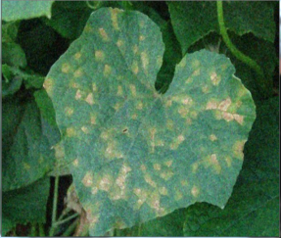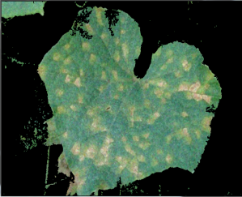
- (b)
Figure 2: (a): input image, (b): segmented image
- Detection: at this phase the segmented image will be converted to HSV color space. Then thresholding will be applied based on predefined HSV color values, these values represent the infected areas color. The output image from thresholding contains the infected areas. Finally, connected component algorithm is applied to remove large size and small size regions of the image. In addition, the number of pixels in the result image will be counted as a ratio of the overall pixels to determine the severity of the disease.

- Experiments and Results
In this approach, the system is tested on 100 samples from which 50 samples are infected with downy mildew disease, 50 samples are not infected and. We divide the programming phase into two sub-phases which are simulation and real programming. Simulation phase was done using Matlab with image processing toolbox. The system was able to classify cucumber leaves as infected or not infected correctly after using Thresholding. The real programming phase was performed using OpenCV and C++ where the computational time aspect was taken into consideration.
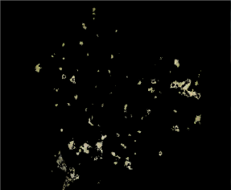
- (b)
Figure 3: (a): the input image, (b):infected areas
The results show that we were able to detect 50 infected images as infected i.e. 100% and 45 of the not infected images as not infected i.e. 90%.
- Conclusion
A computer based method that can read a captured image of a plant leaf and give a statement and numbers that describes infection of this leaf from the image with minimum user intervention is innovated. The project can analyze a cucumber leaf then decide whether it is infected or not in addition to the degree of disease severity
- Acknowledgement:
The authors would like to thank the Deanship of Graduate Studies and Scientific Research for supporting this project.

- References:
[1] Olsen, Mary W. (2011). Plant disease management. Arizona Cooperative Extension, 1033, 1.
[2] Becker, Ron, & Miller, Sally A. (2009). Managing Downy Mildew in Organic And Conventional Vine Crops. The Ohio State University extension, 3127, 1-2.
[3] Kulkarni, Anand.H, & Patil R. K, Ashwin.(2012).
Applying image processing technique to detect plant diseases. International Journal of Modern Engineering Research, 6645, 1-2.

